🡪Business cycle & phases:

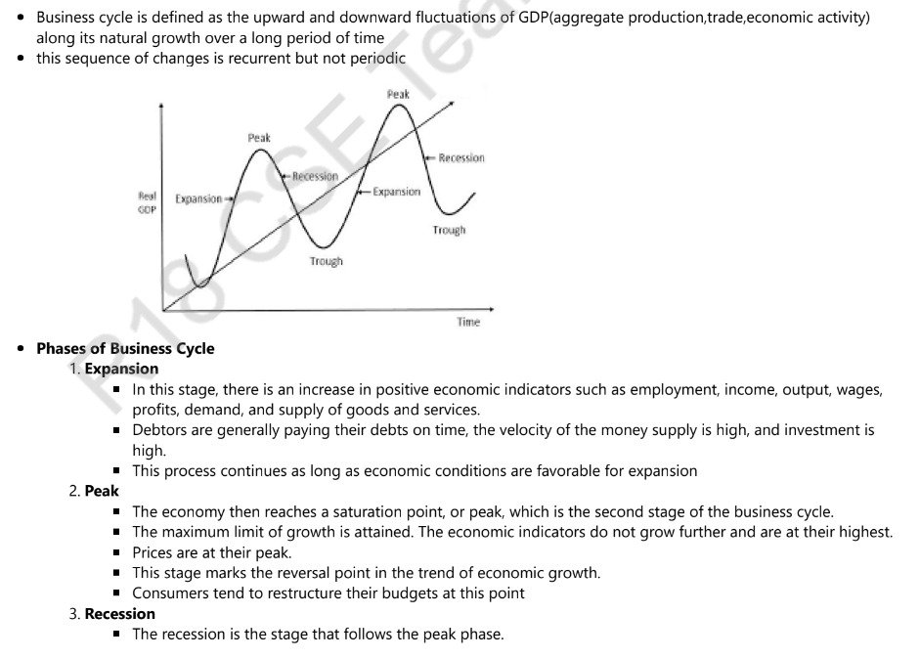

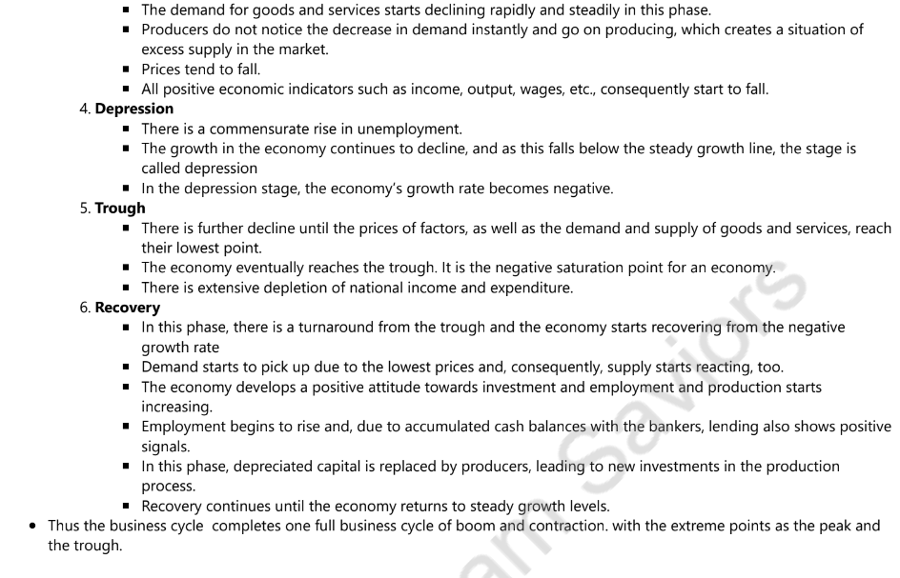

* Types of inflation

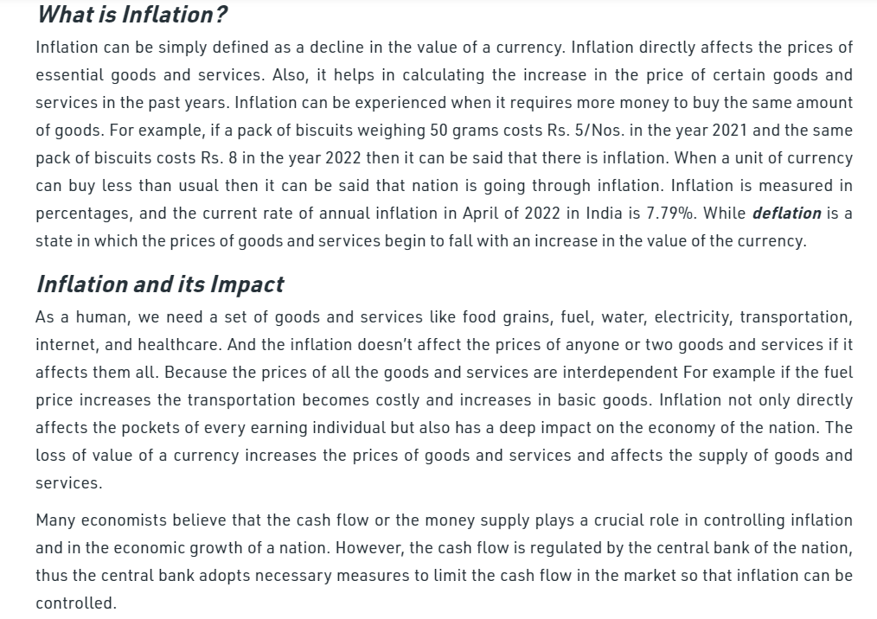

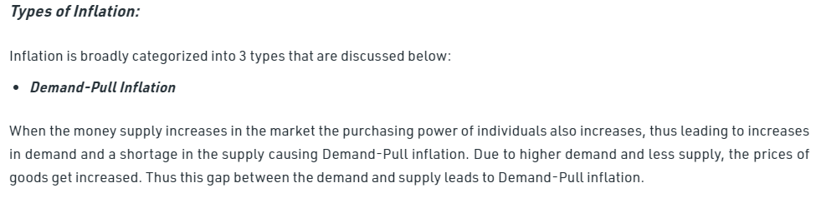

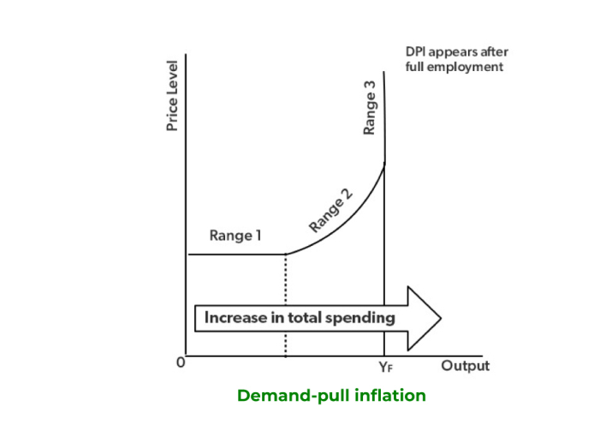

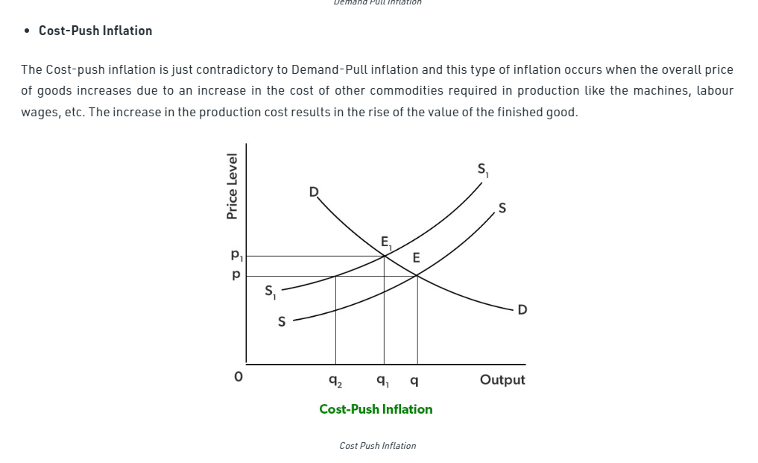

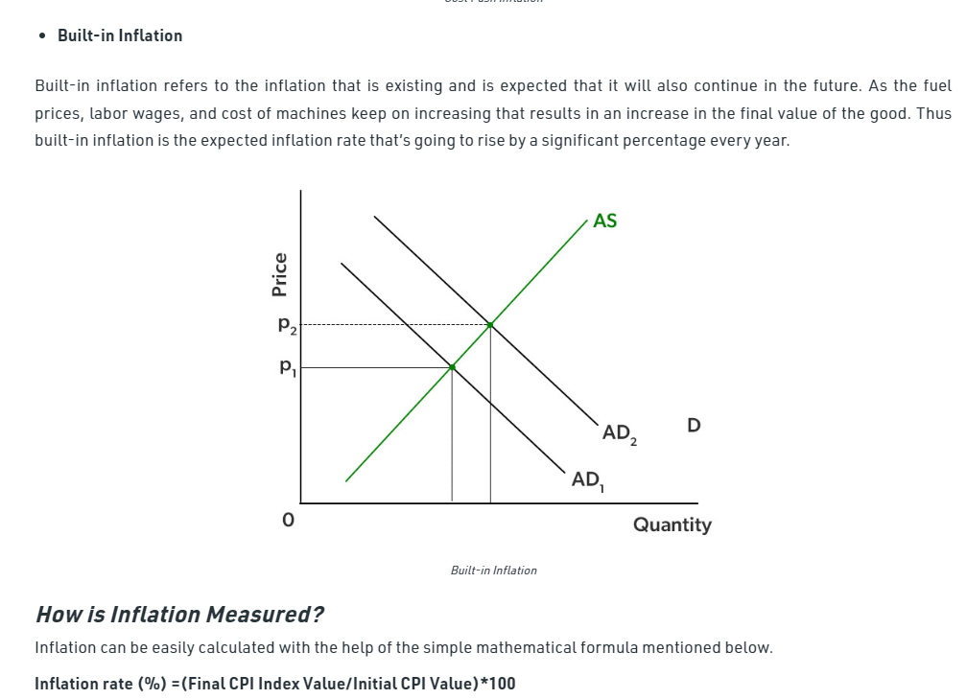

* Oligopoly and determine price and output

<https://www.toppr.com/guides/fundamentals-of-economics-and-management/forms-of-market/price-and-output-determination-under-oligopoly/#:~:text=An%20oligopoly%20exists%20between%20two,or%20service%20is%20called%20oligopoly>.

* Difference between GDP and GNP

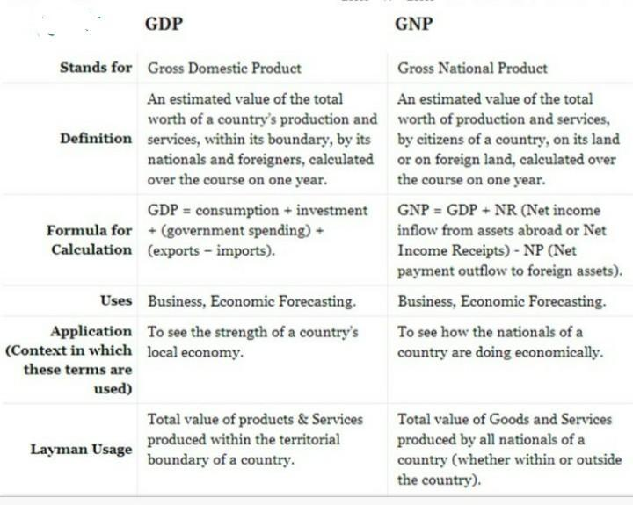

4th unit

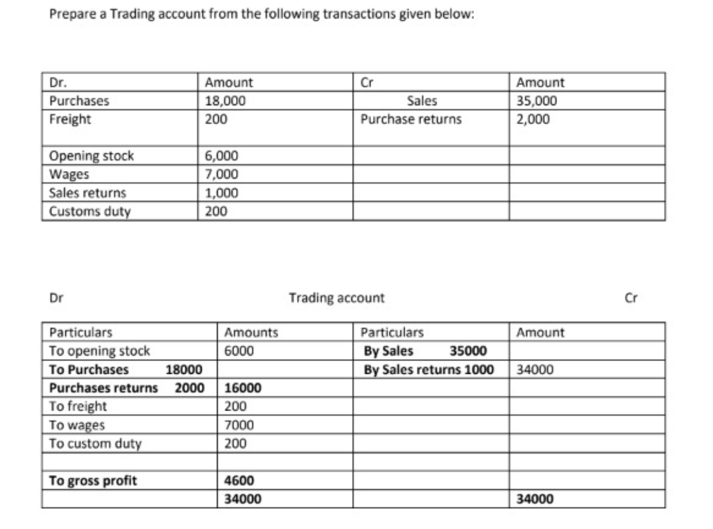

5th unit:

* Types of Ratios

